**Traffic Sign Recognition**

**ENPM673 P2 Report**

**Yash Manian**

The pipeline followed for this project was largely inspired by the Mathworks Digit classification guide:

<https://www.mathworks.com/help/vision/examples/digit-classification-using-hog-features.html>

**Denoising the image**

Before performing any mathematical analysis on the image, it is important to smooth out the high frequency noise in the image. I used a Gaussian kernel to smooth out the noise before processing. The spread of the Gaussian was experimentally set to 2.

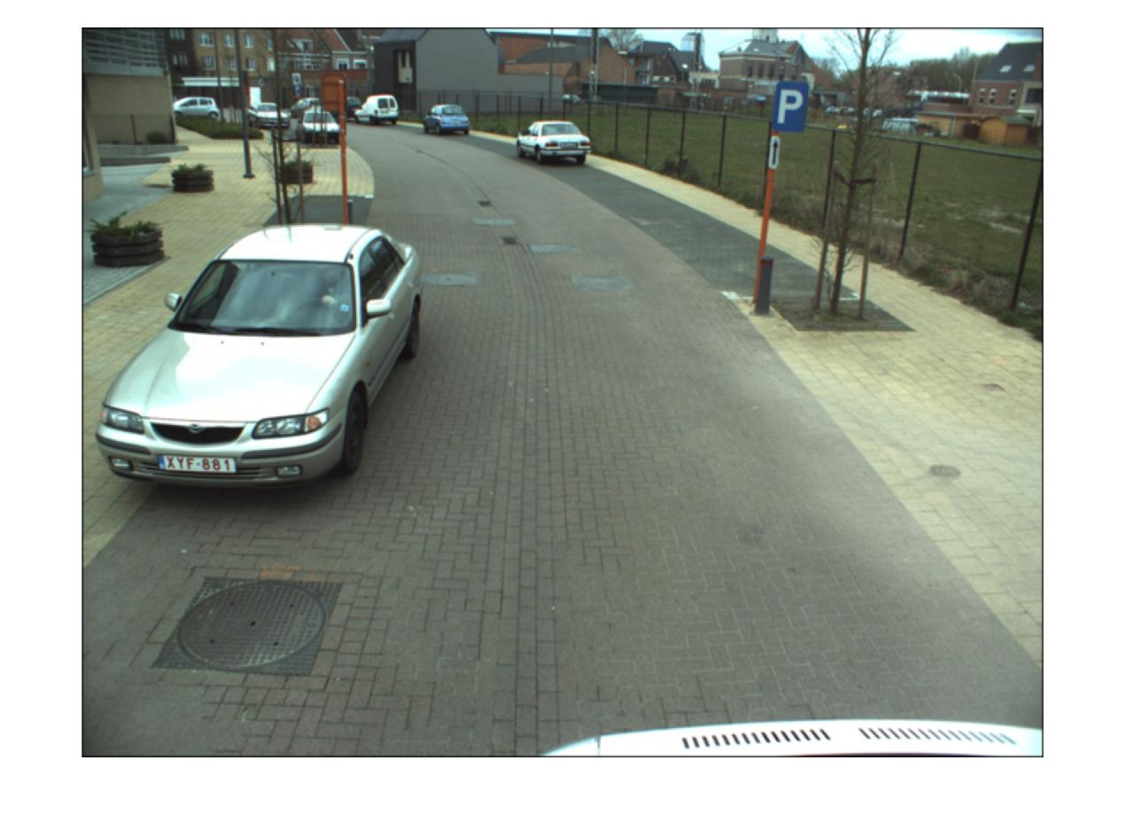

**R and B renormalization**

A weighted RGB renormalization was used to make the red and blue regions to stand out. The ideal weights were determined through experimentation.

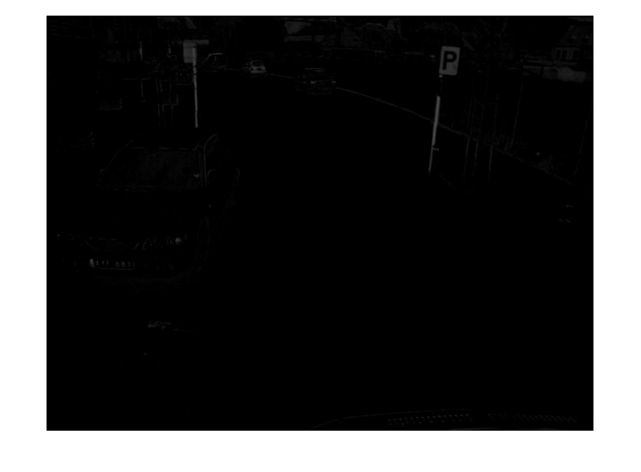

**Maximally Stable Extremal Regions**

Usually, the solution for identifying continuous patches of color is to use thresholding. However, simple color thresholding may be a bit unreliable in picking out traffic signs reliably every frame.

Thus MSER (Maximally Stable Extremal Regions) was used to identify contiguous bodies in the image. This reduces the regions of interest, and makes classification easier.

The bottom half of the image is blocked, so that no unnecessary features are detected. After masking the image, the MSER is run on the renormalized RGB image, which allows it to detect the highlighted sections of the image. A bounding box is plotted around the region of interest, and is then cropped for classification. For MSER, the VLFEAT toolbox was used.

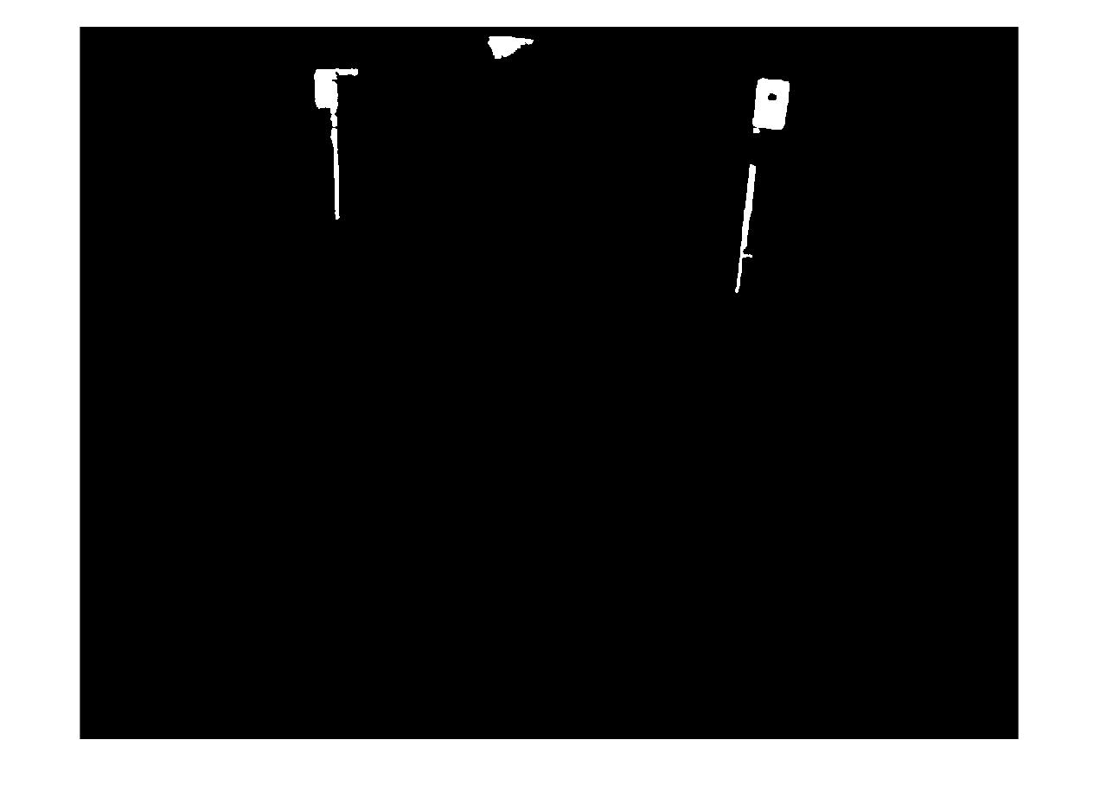

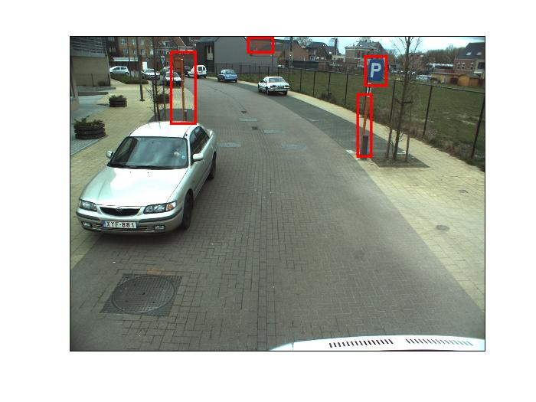

**HOG based SVM training**

To classify the traffic signs, I have trained a multi-class SVM on the Histograms of Gradients (HoG) of training samples of the signs. HoGs of multiple traffic signs are taken as training data, and the classifier for the SVM is trained. Once trained, another dataset of test images is run through the classifier to verify if the predicted labels are correct. This classifier is stored so that it can be used without having to run the SVM training all over again.

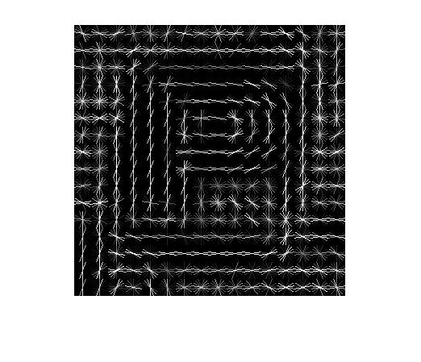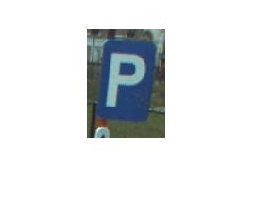

**Classifying road signs using SVM classifier**

The MSER features are cropped and resized, and the HoG of those images is determined. Once the HoG of the cropped feature is classified by the SVM, the appropriate image is chosen to display beside it.

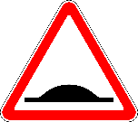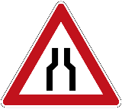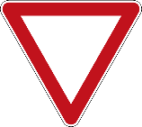

**Eliminating errors**

There are a lot of false detections from the MSER feature detection. These detections are reduced through two different criteria:

The first one is that the aspect ratio of all the traffic signs will be the almost the same. Hence a range of acceptable aspect ratios was defined, so that the detections with different aspect ratios aren’t considered for classification.

The second filter is the classification score. This denotes the probability of the classified data point belonging to a class. A threshold was determined for filtering out the not so probable detections to classify only best case in terms of probabilities.

The final result is as follows:

